Name _____________________________________________ Date _____________________

THE NEW COLOSSUS (1883) - by Emma Lazarus
Before reaching Ellis Island, immigrants were greeted by the Statue of Liberty. A gift from France to the United States, the State of Liberty opened in 1892 and immediately became a symbol of welcome for immigrants arriving on American shores. In 1903, a poem was engraved on a plaque and mounted on the pedestal of the statue. The New Colossus tells the story of millions of immigrants coming to the United States.
Read the poem a respond to the following questions
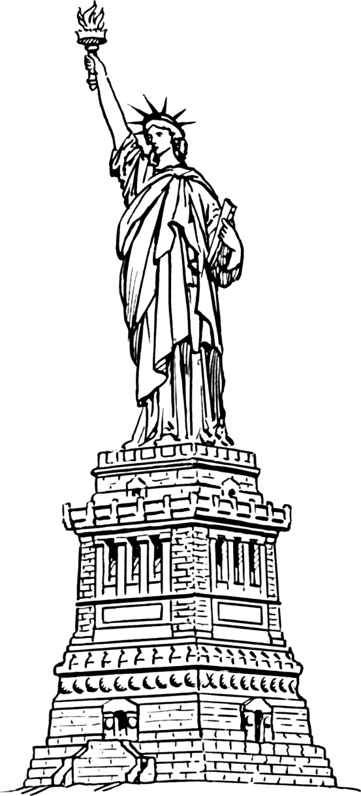
Not like the brazen giant of Greek fame,
With conquering limbs astride from land to land;
Here at our sea-washed, sunset gates shall stand
A mighty woman with a torch, whose flame
Is the imprisoned lightning, and her name
Mother of Exiles. From her beacon-hand
Glows world-wide welcome; her mild eyes command
The air-bridged harbor that twin cities frame.
"Keep ancient lands, your storied pomp!" cries she
With silent lips. "Give me your tired, your poor,
Your huddled masses yearning to breathe free,
The wretched refuse of your teeming shore.
Send these, the homeless, tempest-tost to me,
I lift my lamp beside the golden door!"
1. What is the "brazen giant of Greek fame"? (Hint: It relates to one the Seven Wonders of the Ancient World)

2. Explain the line, "Give me your tired, your poor, your huddled masses yearning to breathe free."

3. What does the "Golden Door" signify?

4. What does the poem mean to you?

