February 17, 2014
American Studies
Mr. Gordon

"It is the mark of an educated mind to be able to entertain a thought without accepting it." -Aristotle

Debate: Viewpoints on Immigration
The issue of immigration is prominent in the United States today. Currently in Washington D.C., Congress is discussing and debating whether or not the country's policies on immigration are appropriate, and how they might be changed. In order to understand the various viewpoints on immigration, we will be conducting three class debates.
With the overarching theme of immigration in mind, we will be debating and discussing three topics from opposing viewpoints: General Immigration, Illegal Immigration, and Immigration Policy. With two opposing viewpoints for each of the three topics, there will be six different debate teams. You will be assigned to teams of two or three, and together you and your team will research and prepare an argument for your viewpoint. You may be assigned a viewpoint that you do not agree with. However, being able to advocate for various viewpoints is an important skill to learn. This will culminate in a fifteen-minute debate, with each winning team to be judged by the rest of the class and the teacher.

Steps
- Assign groups
- Acquire sources to support arguments (and to counter opposing arguments)
- Write argument - to be presented as 2 to 5-minute opening statement
- Debate
- Class votes for winner - teacher has final say

Step 1: Assign Groups
General Immigration
- Pro-Immigration __________________ ___________________ _________________
- Anti-Immigration __________________ ___________________ _________________
Illegal Immigration
- Pro-Illegal Immigration ________________ _________________ _________________
- Anti-Illegal Immigration ________________ _________________ _________________
Immigration Policy
- Policy to Increase Immigration
_______________________ _______________________ ______________________
- Policy to Decrease Immigration
_______________________ _______________________ ______________________

Round 1: General Immigration
 | Pro-Immigration | Anti-Immigration
1. | The amount of immigrants coming to the United States is too much. | There are too many immigrants coming to the United States
2. | Immigration has helped the United States | Immigration has hindered the United States
3. | Having a variety of cultures and languages in America benefits everyone | Having a variety of cultures and languages in America is harmful

Round 2: Illegal Immigration
 | Pro-Illegal Immigration | Anti-Illegal Immigration
1. | There doesn't need to be a wall between Mexico and the United States nor does there need to be more Immigration and Naturalization Service border patrol agents | There needs to be a wall between Mexico and the United States along with more Immigration and Naturalization border patrol agents
2. | Illegal immigrants do not take away jobs from U.S. citizens | Illegal immigrants take away jobs from U.S. citizens
3. | Illegal immigration has not harmed America | Illegal immigration is harmful to America

Round 3: Immigration Policy
 | Policy to Increase Immigration | Policy to Decrease Immigration
1. | U.S. immigration policy should make it easier to immigrate here | U.S. immigration policy should be more selective in who it allows to immigrate here
2. | If a country is having economic, political, or social problems, the U.S. should allow its residents to come here for a better life | Even if a country is having economic, political, or social problems, the U.S. should prevent those residents from coming here in case they would cause problems
3. | Those who come to the United States do not need to learn English | Everyone who comes to the U.S. should be required to learn English

Step 2: Acquire reliable sources to support your arguments.
Using reliable websites, find at least 8 sources to support your argument as well as the standpoints that go along with your argument (as seen on the previous page). The opposing team may ask you the source of your information. If you want your argument to hold, you must be able to answer them with a reliable source. You should also be able to expect what the opposition will say for their argument, and be able to counter it with your own sources.
Debate Organizer
My argument is that:

Evidence for my argument:

Evidence against my argument:

Rebuttal to evidence against my argument:

Step 3: Write argument
Using your resources, you will construct an opening statement for your argument. This will be read for your opening 2 to 5-minute statement at the beginning of the debate. Your statement should be easily understood and contain the following:
- Some background to the issue at hand
- A clear explanation of your argument
- Evidence for your particular argument as well as each of the three stances that go with your argument
- Evidence against the opposing argument
- A conclusion to wrap up your overall argument

Step 4: Debate
Format
- Opening argument for pro side (Pro-Immigration, Pro-Illegal Immigration, Policy for Increased Immigration) - 2 to 5 minutes
- Argument for con side (Anti-Immigration, Anti-Illegal Immigration, Policy for Decreased Immigration) - 2 to 5 minutes
- Each team confers to prepare their rebuttals
- Rebuttal for con side - 1 to 4 minutes
- Rebuttal for pro side - 1 to 4 minutes
- Each team confers to prepare one question to ask opposing side. This question period will be a two-sided conversation
- Pro side asks question to con side. Con side has 1-2 minutes to respond
- Con side ask question to pro side. Pro side has 1-2 minutes to respond
- Class and teacher discuss debate. Questions may be asked to debate participants. After, there is a vote for winner.

Debate Scoring Guide

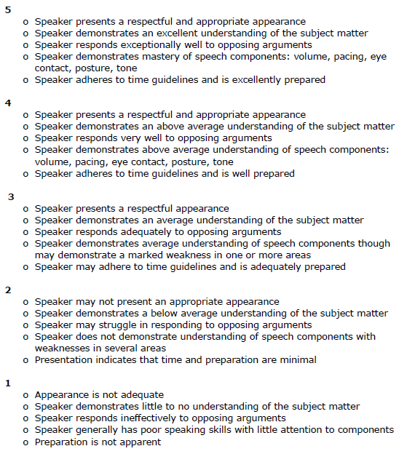

*Extra credit for well-thought-out questions to debaters while in audience during question period

